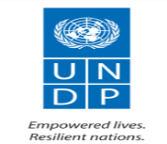
Enhancing Nigeria’s AfCFTA Export Readiness: Empowering MSMEs for Intra-Africa Trade

Project Number: 01004345

2025 Quarter 3 Progress Report
(July – Sep 2025)

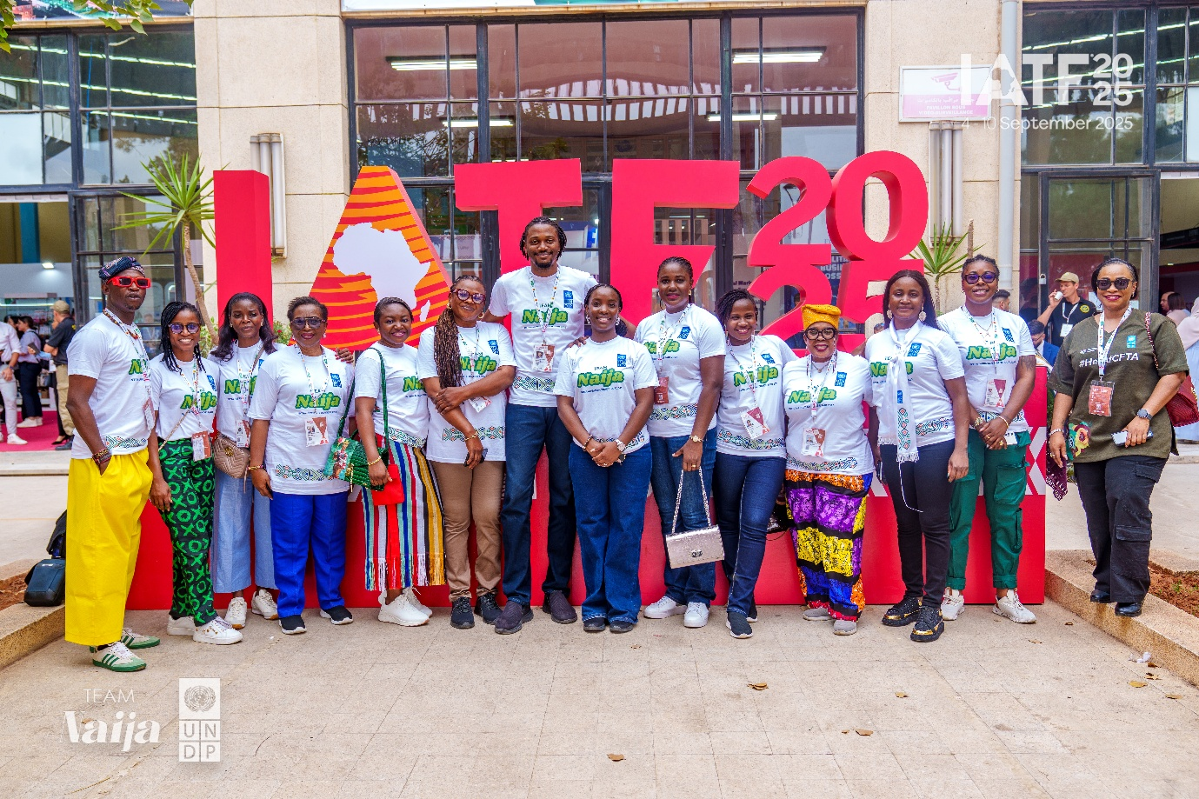

Source: UNDP
UNDP sponsored delegates at IATF 2025 in Algeria
Project Summary | Country: Nigeria  Project Duration: April to June 2025  Total Project Budget: US$ 500,000  Total Annual Budget (year): US$500,000  Cumulative expenditure (including for the reporting period): US$ 259,382.72  Donor Contributions  Contact Persons: Clare Henshaw  Team Lead, Inclusive Growth Unit  Tel. +234 7033 757 721  Email: clare.henshaw@undp.org
  Donor | Annual budget US$
  UNDP TRAC 2 | $300,000
Implementing Partner(s)/Responsible Party(ies): UNDP, WCIMMA

Table of Contents
Acronyms 3
1. Executive Summary (Max 1 ½ page) 4
2. Situation Background (Max 1 page) 6
Progress towards development results 6
a. Contribution to longer term results (Max 1 page) 6
a. Progress towards project outputs (Max 1 ½ page per output) 7
b. Human Interest Story (max 1 page) 9
2. Cross cutting issues 10
a. Gender results (max 1/2 page) 10
b. Partnerships (maximum 1/2 page) 10
c. Environmental Considerations (max 1/2 page) 10
d. South to South and Triangular Cooperation (max 1/2 page) 11
e. Strengthening capacity of national institution(s)(max 1/2 page) 11
1. Monitoring of Project Activities (Max 1 page) 11
a. Risk management matrix (Q3, 2025) (max 1/2 page) 11
2. Challenges (Q3, 2025) (max 1/2 page) 12
3. Lessons Learned (Q3, 2025) (max 1/2 page) 12
4. Evidence (Q2, 2025) 13
5. Financial Summary 14

Acronyms
UNDP | United Nations Development Programme
WCCIMA | Women Chamber of Commerce Industry Mines and Agriculture
AfCFTA | Africa Continental Free Trade Area
FMITI | Federal Ministry of Industry, Trade and Investments
SMEDAN | Small and Medium Enterprise Development Agency of Nigeria

Executive Summary (Max 1 ½ page)

Nigeria, Africa’s largest economy and most populous nation, has the potential to become a regional trade powerhouse under the African Continental Free Trade Area (AfCFTA). However, structural barriers including weak production capacity, fragmented policies, limited access to finance, and inadequate trade infrastructure continue to constrain the competitiveness of Micro, Small, and Medium Enterprises (MSMEs), particularly those led by women and youth.

In response, United Nations Development Programme Nigeria (UNDP Nigeria) is implementing the Enhancing Nigeria’s AfCFTA Export Readiness project - an integrated initiative aimed at equipping MSMEs with the tools, networks, and capabilities to access and compete in regional markets. The project strengthens institutional capacities, expands market access, and builds the export readiness of MSMEs through targeted capacity-building, trade facilitation, and strategic partnerships.

During Q3 2025, UNDP recorded notable progress in advancing this agenda. Twelve Nigerian MSMEs showcased their products at the Intra-African Trade Fair 2025, generating onsite sales estimated at $10,000–$12,000 and securing more than 50 follow-up meetings with potential buyers and distributors. In Abia State, 20 desktop computers were delivered to the Aba Export Growth Lab to strengthen its role as a subnational export support platform. Additionally, through partnership with Small and Medium Enterprises Development Agency of Nigeria (SMEDAN), the design of a national MSME Growth Hub advanced to support young creators and enterprises with business services, capacity building, digital enablement, and market access.

Key Achievements
Main achievements of the project so far include:

- Participation of Nigerian MSMEs at the 4th Intra-African Trade Fair (IATF) 2025
UNDP Nigeria supported the participation of 12 Nigerian MSMEs at Intra-African Trade Fair (IATF) 2025, showcasing products across priority value chains. Total onsite sales recorded by participating businesses were estimated at $10,000–$12,000 combined, with variations by sector and product category. Beyond immediate sales, the real strength of IATF 2025 lies in the structured follow-up pipeline established for participating MSMEs. Collectively, businesses reported over 50 scheduled follow-up meetings with prospective buyers, distributors, and partners which created clear pathways for deal conversion, expanded market access, and long-term trade relationships.
- Abia Export Growth Lab
UNDP Nigeria delivered 20 desktop computers to the Aba Export Growth Lab as part of its broader support to strengthen the lab’s operational capacity as a state-level export support platform. The lab now provides digital infrastructure for MSMEs to access training, market intelligence, and export facilitation services, positioning Abia as a key node in Nigeria’s subnational export strategy.

- MSME Growth Hub (SMEDAN Partnership)
In partnership with Small and Medium Enterprises Development Agency of Nigeria (SMEDAN), UNDP advanced the design of a national MSME Growth Hub to support young Nigerian creators and MSMEs. The hub will offer business support services, capacity building, digital enablement, and market access solutions; building a structured platform to strengthen competitiveness and accelerate entry into domestic and regional value chains.

Key Challenges
One of the main implementation challenges in Q3 was delays from state partners, particularly Abia State, in kickstarting the planned beneficiary training activities under the Export Growth Lab initiative. These delays slowed down the overall rollout timeline and affected the sequencing of capacity-building interventions for MSMEs. This underscores the need for stronger implementation coordination mechanisms and clearer timelines with state partners to ensure timely delivery of project milestones.

Lessons Learned
The following initial lessons have been identified:
- Strong Local Ownership Drives Sustainability: When state partners take active leadership, programme activities move faster and create stronger community buy-in.
- Flexible Implementation Improves Responsiveness: Building room for adaptive planning allows quick adjustments when state-level processes slow down.

Situation Background (Max 1 page)

Nigeria, with a population exceeding 200 million and the largest economy on the continent, has immense potential to shape and drive regional trade and economic prosperity across Africa. Yet, despite its scale, the country remains underrepresented in intra-African trade accounting for just 4.5% of total trade in 2022. Persistent structural barriers such as weak production capacity, fragmented policies, inadequate trade infrastructure, and limited digital adoption continue to constrain Nigeria’s ability to fully leverage regional integration. These challenges weigh most heavily on micro, small, and medium-sized enterprises (MSMEs), particularly those led by women and youth, who face systemic obstacles to scaling their businesses and participating in cross-border trade.

The African Continental Free Trade Area (AfCFTA) presents a historic opportunity to change this trajectory. By eliminating up to 90% of intra-African tariffs and creating a single continental market, the AfCFTA can boost competitiveness in high-growth sectors such as fashion, agro-processing, digital services, tourism, and light manufacturing. Given that MSMEs contribute over 50% of Nigeria’s GDP and employ more than 80% of its workforce, empowering these enterprises with the right skills, tools, and market linkages is key to unlocking inclusive growth.

To advance this agenda, United Nations Development Programme Nigeria (UNDP Nigeria) is scaling its efforts through the project Enhancing Nigeria’s AfCFTA Export Readiness: Empowering MSMEs for Intra-Africa Trade. Building on the 2024 pilot phase which delivered technical support to trade institutions, opened new business-to-business corridors, the 2025 scale-up will deepen impact and institutionalize mechanisms that accelerate the growth of export-ready enterprises across strategic value chains.

Working closely with Federal Ministry of Industry, Trade and Investment, Nigerian Export Promotion Council, and other national and regional partners, UNDP will focus on three core priorities: strengthening MSME export capacity, improving institutional trade facilitation, and expanding market access through strategic partnerships.

The project’s expected outputs are:
- Integrated Export Readiness and Access-to-Finance Programmes for MSMEs in target states
- Strengthened Local Tourism, Trade in Services, and Value Chains for Job Creation
- Establishment of Community Entrepreneurship Hubs to democratise access to support for MSME growth

Progress towards development results

Contribution to longer term results (Max 1 page)
United Nations Sustainable Development Cooperation Framework (UNSDCF)/Country Programme Document (CPD) Outcome <2>: By 2027, Nigeria sustains inclusive economic growth and development that provides equitable opportunities for decent employment and livelihoods.
Summary achievements based on CPD Outcome <2>
CPD outcome Indicator | Indicator Target | Indicator Status | Status (Ongoing, Delayed or Completed) | Summary achievement as of Q2 2025
Output 1: Strengthened MSME Competitiveness and Local Service Economies through Integrated Market Readiness, Inclusive Finance, and Community-Based Innovation Platforms  Outcome 2: By 2027, Nigeria sustains inclusive economic growth and development that provides equitable opportunities for decent employment and livelihoods. | 6000  2 | 1012  0 | Ongoing  Ongoing | Twelve Nigerian MSMEs were provided with targeted investor readiness training ahead of their participation at IATF and received on-site support from investment experts during the event.
C ‘` Overall Status |  |  |  | Ongoing

Guidance: Please populate the table above. No narrative section is required

Progress towards project outputs (Max 1 ½ page per output)
Project Output 1: Strengthened MSME Competitiveness and Local Service Economies through Integrated Market Readiness, Inclusive Finance, and Community-Based Innovation Platforms
Summary achievement against 2025 Annual Work Plan (AWP) target
Indicator (as they appear in the AWP) | Indicator Target (2025)  (AWP indicator targets) | Indicator  Status | Status: Ongoing, Delayed, Completed | Summary achievement during the quarter (provide gender disaggregate data where available)
[1] : Number of women and youth MSMEs with increased market access and competitiveness to facilitate trade in goods and services. | 3000 | 1014 | Ongoing | 14 businesses that participated in IATF 2025. Notably, 9 of these 14 businesses were women-owned, reflecting strong female participation in export readiness and market access initiatives.
 | Overall status |  |  | Ongoing

Indicator (as they appear in the AWP) | Indicator Target (2023)  (AWP indicator targets) | Indicator  Status | Status: Ongoing, Delayed, Completed | Summary achievement during the quarter (provide gender disaggregate data were available)
[2] : Number of community-based hubs or platforms established and operationalized for MSME innovation and entrepreneurship. | 2 | 0 | Ongoing | UNDP, in collaboration with SMEDAN, finalized the design of a digitally enabled MSME Growth Hub at the Idu Common Facility Centre. The space will be refurbished and solarized to support small businesses with access to shared production equipment, digital infrastructure, and tiered business support. The implementation of the design has been advertised, with completion targeted by the end of Q4 2025.  UNDP Nigeria delivered 20 desktop computers to the Aba Export Growth Lab as part of its broader support to strengthen the lab’s operational capacity as a state-level export support platform. The lab now provides digital infrastructure for MSMEs to access training, market intelligence, and export facilitation services, positioning Abia as a key node in Nigeria’s subnational export strategy.
 | Overall status |  |  | Ongoing

Description of Results (Should be based on sequential order of each output indicators listed in the table above)
Nigeria’s participation at Intra-African Trade Fair 2025 marked a strategic milestone in advancing inclusive trade, investment facilitation, and private sector competitiveness under African Continental Free Trade Area (AfCFTA). Supported by United Nations Development Programme (UNDP) and Welcome2Africa International, twelve MSMEs showcased Nigerian enterprise across agribusiness, fashion, cosmetics, and light manufacturing. The delegation’s objectives focused on expanding business access to North African markets, securing investment and financing linkages, and advancing policy visibility. IATF 2025 moved beyond traditional exhibitions to provide a transaction-focused platform for B2B and B2C engagement, creating tangible opportunities for scaling Nigerian exports.
The outcomes were both commercial and strategic. Total onsite retail sales across Nigerian exhibitors were estimated at USD 10,000–12,000, with businesses such as Chenche and Mak Nisy Collections recording the highest transactions in fashion and accessories. More critically, over 50 structured follow-up meetings were secured with distributors, buyers, and investors, laying the foundation for long-term market entry. High-value negotiations emerged from agribusiness (notably Thistleberry Food Co. Ltd’s indicative cashew supply deal), cosmetics (Moore Organics’ distributorships across North Africa), and cocoa value chains (Loom Craft Chocolate’s export discussions with Japanese buyers). Collectively, the pipeline of deals under negotiation exceeds USD 150 million, anchored in both commodity trade and women-led enterprise expansion.
Beyond trade transactions, IATF amplified Nigeria’s regional visibility through participation in CANEX Runway, Deal Room sessions, innovation competitions, and structured policy dialogues. Nigerian SMEs were featured prominently in Algerian media, while high-level engagements with ECOWAS, the Ghana Standards Authority, and private sector buyers opened new regional trade corridors. Women-led enterprises represented two-thirds of Nigeria’s delegation, reinforcing the country’s leadership in inclusive trade. IATF 2025 thus provided not only a platform for immediate business opportunities but also a strategic lever for long-term market integration and AfCFTA-aligned growth.
Additionally, in partnership with Small and Medium Enterprises Development Agency of Nigeria (SMEDAN), UNDP advanced the establishment of a digitally enabled MSME Growth Hub at the Idu Common Facility Centre in Abuja. The hub is designed as a shared innovation and production space, providing access to modern equipment, digital infrastructure, and tiered business development support. Its strategic purpose is to strengthen enterprise competitiveness, foster local manufacturing, and accelerate access to domestic and regional value chains.
The design phase of the hub was finalized in Q2 2025. Refurbishment and solarization are ongoing to ensure reliable and sustainable operations. The implementation of the design has been advertised, with completion targeted for the end of Q4 2025. Once operational, the hub will serve as a key platform to support young creators, MSMEs, and export-ready enterprises with business advisory, product development support, and market linkage facilitation.
Finally, UNDP deepened its collaboration with Abia State to strengthen the state’s role as a subnational trade node under AfCFTA. As part of this support, 20 desktop computers were delivered to the Aba Export Growth Lab to enhance its digital infrastructure and operational capacity. The Lab will serve as a key support platform for MSMEs in Abia and the Southeast, providing export readiness training, market intelligence, and facilitation services for access to regional value chains.
While progress has been made on infrastructure, implementation experienced delays in Q3 due to slower state-level processes in launching the first phase of beneficiary training. These delays underscore the need for stronger implementation coordination and clearer delivery timelines with state partners. Once training begins, the Lab is expected to directly support women- and youth-led MSMEs in building export capacity, thereby strengthening Nigeria’s subnational competitiveness under AfCFTA.

Human Interest Story (max 1 page)
Adebisi Odeleye — From Lagos to North Africa’s Beauty Market
At Intra-African Trade Fair 2025, Ms. Adebisi Odeleye, founder of Moore Organics, stood out as one of the most remarkable faces of Nigeria’s emerging beauty and wellness industry. Adebisi arrived at the fair with a clear goal: to show that African-made cosmetics could compete on quality, appeal, and scale with any global brand. Over the course of a few days, she did far more than that.

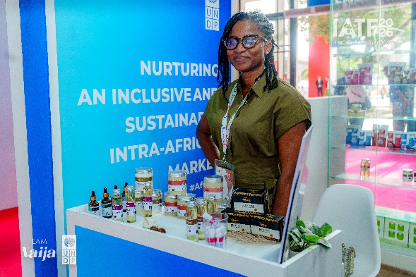
Adebisi recorded approximately USD 2,000 in onsite sales. A strong signal of the market’s appetite for Nigerian shea-based products. But her real breakthrough came when an Algerian distributor placed an order for 10,000 units of Moore Organics’ signature shea body products. This deal, forged through structured matchmaking sessions, positioned her company to establish a footprint in North Africa’s fast-growing cosmetics market.
Her leadership extended beyond sales. Moore Organics was one of five Nigerian businesses selected to participate in the joint United Nations Development Programme–Economic Community of West African States B2B networking and pitch competition. Adebisi led a pan-African team of cosmetics brands, including Nigeria’s Gush Lifestyle, to emerge as the winning group. Their victory secured 12 months of dedicated market access support from United Nations Development Programme Africa, which will help them expand into new markets and scale production.
This success story was built on solid preparation. Prior to IATF, Adebisi and her peers benefited from targeted investment readiness training and on-ground business development support provided by UNDP. This foundation enabled her to confidently negotiate partnerships, secure a high-volume order, and lead a winning team on a continental stage. Adebisi’s story captures the power of structured support in turning MSMEs into Africa-wide competitors and the growing role of Nigerian women entrepreneurs in shaping the future of intra-African trade.

Cross cutting issues

Gender results (max 1/2 page)
Gender results | Evidence
Gender result 1: 8 women-owned MSMEs participated in IATF | Evidence 1: https://www.undp.org/nigeria/press-releases/undp-facilitates-market-access-nigerian-msmes-iatf-2025

Partnerships (maximum 1/2 page)
Key partners cut across government ministries, departments and agencies (MDAs) at national levels, as well as business support organizations. They include:

- Federal Ministry of Industry, Trade and Investment
- Small and Medium Enterprise Development Agency of Nigeria
- Nigerian Export Promotion Council

Environmental Considerations (max 1/2 page)
The project embeds environmental considerations across the outputs. The project takes into account environmental considerations in both planning and implementations towards the sustainability of the environment.

South to South and Triangular Cooperation (max 1/2 page)
Guidance: List the types of South to South and Triangular Cooperation that the project was involved in during the year. Which countries (1st column) and type of cooperation (2nd column)
Country | Type of cooperation
- Algeria | South-South

Strengthening capacity of national institution(s)(max 1/2 page)
Guidance: Describe national capacity strengthening initiatives and results for the quarter
Institution | Areas of capacity provided | Results achieved
- Nigerian Export Promotion Council | Financial sponsorship | Participation in IATF 2025

Monitoring of Project Activities (Max 1 page)
Monitoring activities conducted during the quarter [ensure alignment to section 3 - how progress was monitored]
Monitoring activity (monitoring visit, output verification, review exercise) | observation or concern | Recommendation | Action taken
Activity 1: Visit to SMEDAN centre to assess readiness for MSME hub and state of mini-grid provided | Persistent power load imbalances and limited utilization of the existing solar mini-grid due to unclear operational management and energy distribution protocols. | Develop and implement a comprehensive operational framework for the MSME Growth Hub, outlining clear responsibilities for power management, maintenance, and space allocation to ensure optimal and sustainable use of the solar system. | UNDP engineers conducted a joint monitoring visit with SMEDAN officials to assess the current technical setup and identify viable long-term solutions. A follow-up technical session was held with the private facility manager and UNDP programme team to define an improved management plan and align on the next steps for system optimization and hub readiness.

Risk management matrix (Q3, 2025) (max 1/2 page)
Risks | Mitigation Measures
Political Risks: Political transitions, leadership changes, or instability in some states and regions can delay implementation and disrupt stakeholder coordination and commitments. | Maintain strong relationships with both political and technical counterparts to ensure programme continuity. Engage state-level civil service actors and institutional focal points to preserve momentum. Leverage existing MOUs to institutionalize commitments beyond political cycles.
Financial Risks: The budget required to scale AfCFTA implementation is limited. | UNDP is intensifying efforts to mobilize and leverage additional resources to scale project implementation.

Challenges (Q3, 2025) (max 1/2 page)
Four major challenges were observed during this quarter:
- Limited Certification and Standards Compliance
A number of participating MSMEs lack the required certifications and quality assurance documentation to export their products under AfCFTA. This remains a critical barrier to market entry, as many regional buyers and distributors require proof of compliance with health, safety, and product standards before finalizing trade deals.

- Logistics and Shipping Constraints
High shipping costs, limited access to efficient logistics services, and delays at ports have significantly increased the cost of doing business for MSMEs. These logistical hurdles undermine the competitiveness of Nigerian products in regional markets and limit the ability of small businesses to fulfill bulk orders.

- Market and Pricing Misalignment Across Borders
Nigerian MSMEs continue to face challenges with pricing competitiveness in regional markets. Production cost structures are often out of sync with what buyers in neighboring countries are willing to pay. This misalignment compounded by weak pricing intelligence has resulted in missed trade opportunities, particularly in bulk commodity exports and light manufacturing sectors.

- Delays from State Partners
One of the main implementation challenges in Q3 was delays from state partners, particularly Abia State, in kickstarting the planned beneficiary training activities under the Export Growth Lab initiative. These delays slowed down the overall rollout timeline and affected the sequencing of capacity-building interventions for MSMEs. This underscores the need for stronger implementation coordination mechanisms and clearer timelines with state partners to ensure timely delivery of project milestones.

Lessons Learned (Q3, 2025) (max 1/2 page)
The following lessons have been identified:
- Strong Local Ownership Drives Sustainability: When state partners take active leadership, programme activities move faster and create stronger community buy-in.
- Flexible Implementation Improves Responsiveness: Building room for adaptive planning allows quick adjustments when state-level processes slow down.
- Targeted Capacity Building Yields Tangible Impact: MSMEs show measurable improvement when provided with practical, sector-specific training on export readiness, certification, packaging, documentation, and trade regulations.
- Access to Markets Must Be Matched with Price Alignment: Regional demand for Nigerian products is strong, but price disparities remain a key barrier. Supporting MSMEs with pricing intelligence, cost-efficient production strategies, and bundled services (e.g., logistics + finance + market access) enhances competitiveness and deal closure rates.

Evidence (Q2, 2025)

- List evidence of achievements of the project towards the outputs during the reporting period

Report Section | Title | URL link
Output 1 | Nigerian MSMEs participation at IATF | https://www.undp.org/nigeria/press-releases/undp-facilitates-market-access-nigerian-msmes-iatf-2025
Output 1 | UNDP partners with Abia State to support economic growth | https://thewhistler.ng/abia-govt-sign-landmark-mou-with-undp-to-boost-economic-growth/

Financial Summary

 |  | Current Annual Budget (US$) | Expenditure (July – September 2025) | % Expenditure
 |  | (July – September 2025) | Expenditure (July – September 2025) | (Cumulative)
Outputs / Activity Result |  |  | Expenditure (July – September 2025)
 |  | A | B | B/A*100
Output 1: Strengthened MSME Competitiveness and Local Service Economies through Integrated Market Readiness, Inclusive Finance, and Community-Based Innovation Platforms

Activity Result 1 | Integrated Export Readiness and Access-to-Finance Programmes for MSMEs in target states | $ 100,000 | $ 92,807.85 | 92%
Activity Result 2 | Strengthening Local Tourism, Trade in Services, and Value Chains for Job Creation | $60,000 | $13,032.19 | 13%
Activity Result 3 | Establishment of Comunnity Entrepreneurship Hubs to democratise access to support for MSME growth | $140,000 | $153,542.68 | 51%
2025 PROJECT GRAND TOTAL |  | $300,000 | $259,382.72

